**BEng/ BEng (Hons) Software Engineering**

**Module** – 4COSC006C - Software Development I

**Lecturer** - Mr. Mithshan jalangan

**Assessment type** –

**Assessment topic –** Tutorial – 1, 2

**Student Name –** S.S.U. Sachintha Chamod

**Student ID –** 20221948

**Tutorial 1**

**Q – 1,**

Write an algorithm for calculating the perimeter and surface area of square, if the length of the sides of the square is given by the user.

1. Start
2. Get the length of one side of square and note it.
3. Use the calculation (4 × one side length) get the perimeter of square.
4. Geth the side length again,
5. Use the calculation to get surface area of square (area = side length × side length)
6. After doing calculation get the answers from step 3 and 5
7. End

**Q – 2,**

Write an algorithm for a program that will

(1) ask for the user’s name, then

(2) print HI and the name. The program will then

(3) ask what year the user was born,

(4) calculate the age, and

(5) print the age.

1. Start
2. Ask the user to input his name.
3. After he entering his name add the word “Hi” before his name
4. Print his name with “Hi” (“Hi Sachintha”)
5. Again, ask the user to enter his birth year.
6. After he is entering his birth year calculate his age
7. Using calculation (age = current year – birth year)
8. After do9ing calculation show to him his age
9. End

**Q – 3,**

Construct an algorithm that will receive an integer from the screen, add 5 to it, double it, subtract 7 from it, and display the final number to the screen.

1. Start
2. Ask the user to enter any integer number.
3. After getting his number add 5 to that integer number
4. Using calculation (Number = user number + 5)
5. Double the answer of step 4.
6. Using calculation (answer = Number × 2)
7. Get the answer from step 6 and subtract from 7.
8. Using calculation (result = answer – 7)
9. Show the final result to the user.
10. End

**Q – 4,**

ABC company needs a weekly payroll report for its salespeople. Input to the program are the salesperson’s name, number, and weekly sales. Output is the salesperson’s name, number, and pay. Each salesperson receives a base weekly pay of $300 as well as a 10% commission on his or her total sales. Develop an algorithm for this.

1. Start
2. Ask the salesman to add his name, his number and his weekly sales
3. Calculate the commission for salesmen’s using (commission = 10/10 × his sales)
4. After the getting commission calculate his salary using commission
5. Using calculation (salary = $ 300 + commission)
6. Show the salesman to his name, his number and his salary.
7. End

**Q – 5,**

Construct an algorithm to read in three values from customer’s bank account: the account balance at the beginning of the month, a total of all withdrawals from the account for the month, and a total of all deposits into the account during the month. A federal tax charge of 1% is applied to all transactions made suing the month. The program is to calculate the account balance at the end of the month by

a. Subtracting the total withdrawals from the account balance at the beginning of the month,

b. Adding the total deposits to this new balance,

c. Calculating the federal tax (1% of total transactions – that is, total withdrawals + total deposits),

d. Subtracting this federal tax from the new balance.

After these calculations, print the final end-of-month balance.

1. Start
2. Ask the user to enter his account balance at the bigging of the month, his total withdrawals and his total deposits during the month.
3. After getting details from user calculate the transactions for get total transactions
4. Using calculation (total transactions = withdrawals + deposits)
5. Then calculate the federal tax fee using calculation (tax = 1/00 × total transactions)
6. After that calculate the balance of the account using calculation (balance = balance at the beginning of the month – withdrawals)
7. Get the answer from step 6 and add the deposits tom that (new balance = balance + deposits)
8. After that subtract the balance form tax using (new balance – tax)
9. After that print the final balance in the account end of that month
10. End

**Tutorial 2**

Q 1,

Draw a flowchart to read three positive integers and to determine the largest and print it on the screen.

Q 2,

A car rental agency charges $34.50 per day for a particular vehicle. This amount includes up to 75 miles free. For every additional mile, the customer must pay $0.25. Design an algorithm using flowcharts to compute the total amount to pay. Use the number of days and the total miles driven by the customer as the input values.

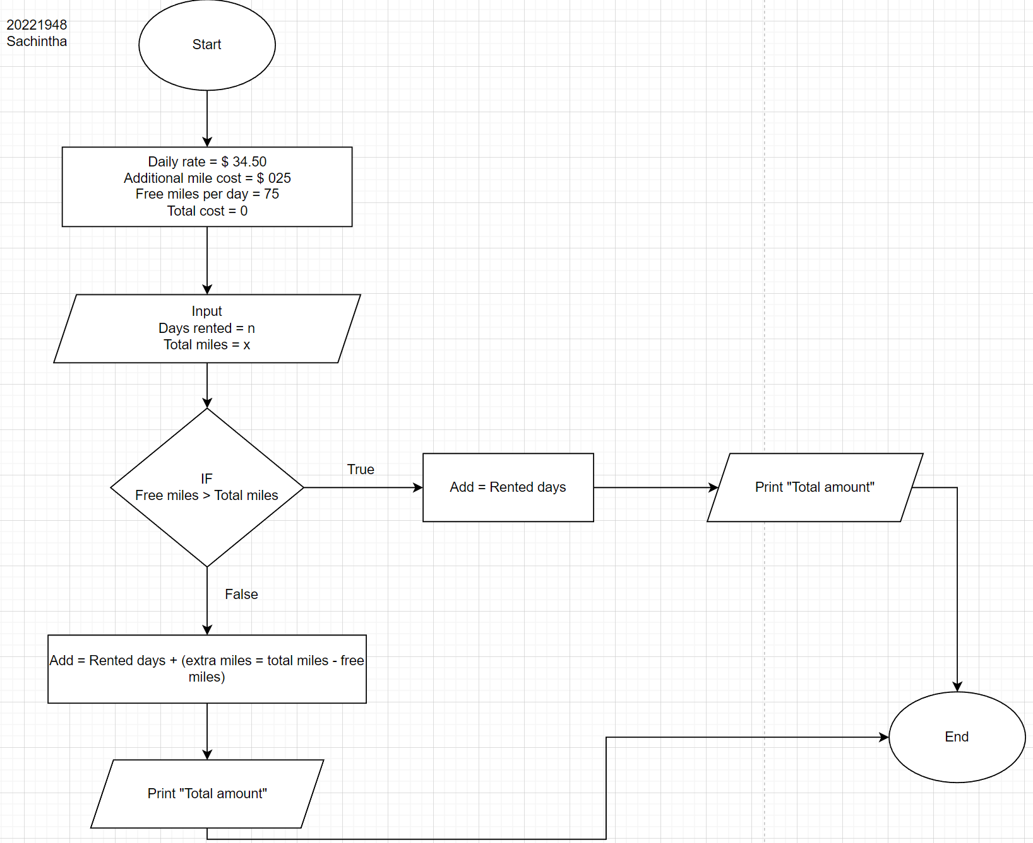

Q 3,

Represent the algorithm using a flowchart that obtains a number representing a month (January = 1, December = 12) and outputs what season the month is in. For the purpose of this program, December-March is considered winter, April-May is considered spring, June-August is considered summer, and September-November is considered autumn.

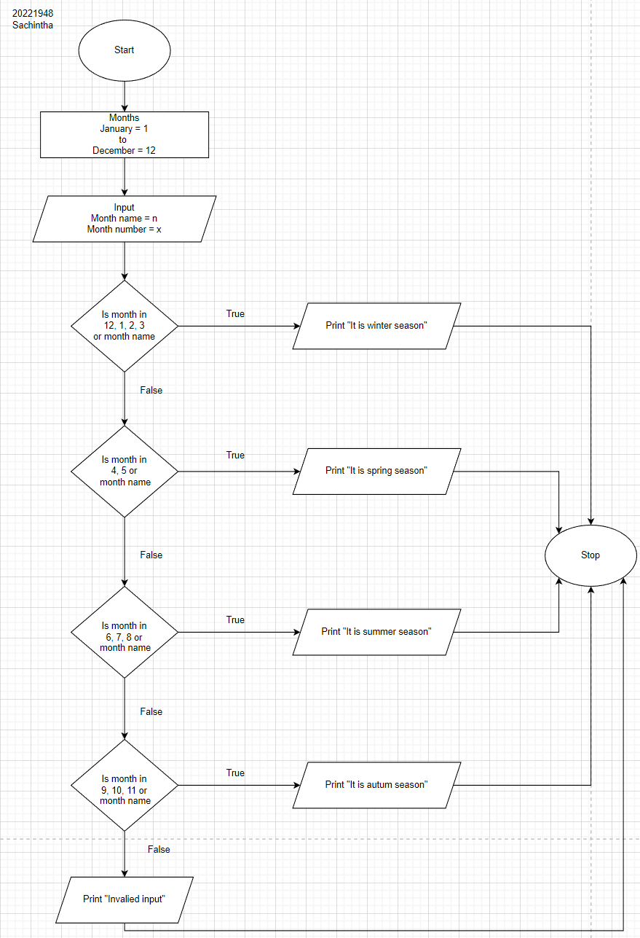

Q 4,

Write the algorithm for a program that calculates the areas of different geometrical figures.

**Triangle,**

1. Start
2. Initialize variables as b =base and h = vertical height
3. Ask the user to input base value and vertical height
4. Calculate the area using calculation “Area = ½ × b × h”
5. Print “Area of the triangle is: ‘Area’
6. End

**Circle,**

1. Start
2. Initialize variables as “r = radius”
3. Ask the user to input radius
4. Calculate the area using calculation “Area = π × r2”
5. Calculate the circumference using calculation “Circumference = 2 × π × r
6. Print the area of the circle of “Area” and
7. Print circumference of the circle of” Circumference”
8. End

**Ellipse,**

1. Start
2. Initialize variables as a = vertical height and b = horizontal length
3. Ask the user to input the values of a and b
4. Calculate the area of ellipse using calculation “Area = πab”
5. Print the area of the ellipse is “Area”
6. End

**Trapezium,**

1. Start
2. Initialize the variables as h = vertical height, a = horizontal length of top and b =- horizontal length of bottom
3. Ask the user to input the length of a, b and h
4. Calculate the area of trapezium using calculation “Area = ½ (a + b) × h”
5. Print the area of trapezium is: “Area”
6. End

Q 5,

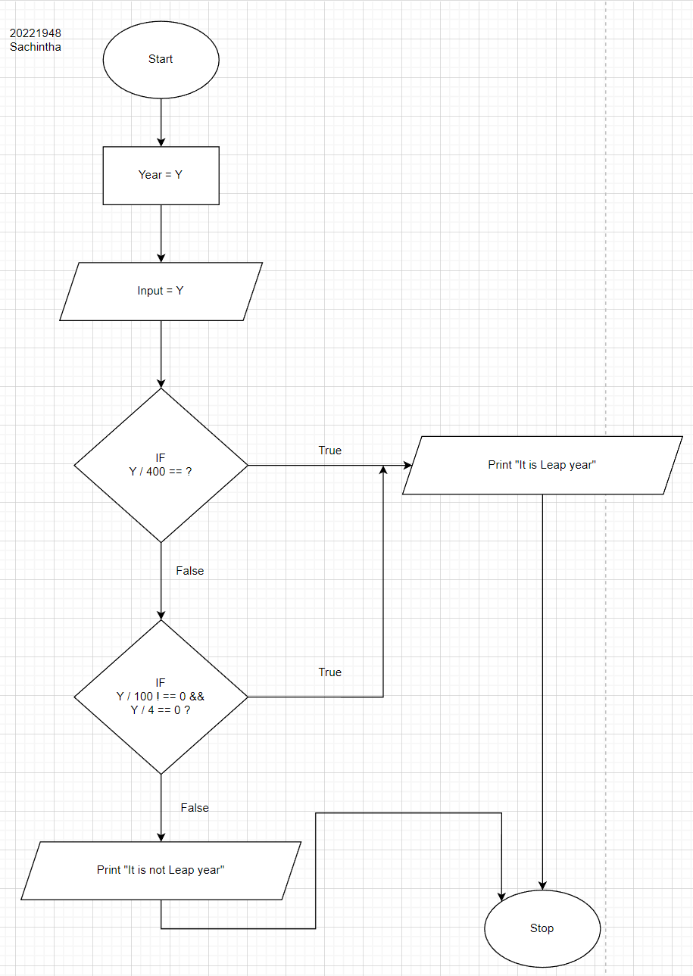Design an algorithm for a program to receive an positive integer as the year, and to determine whether it is a leap year.

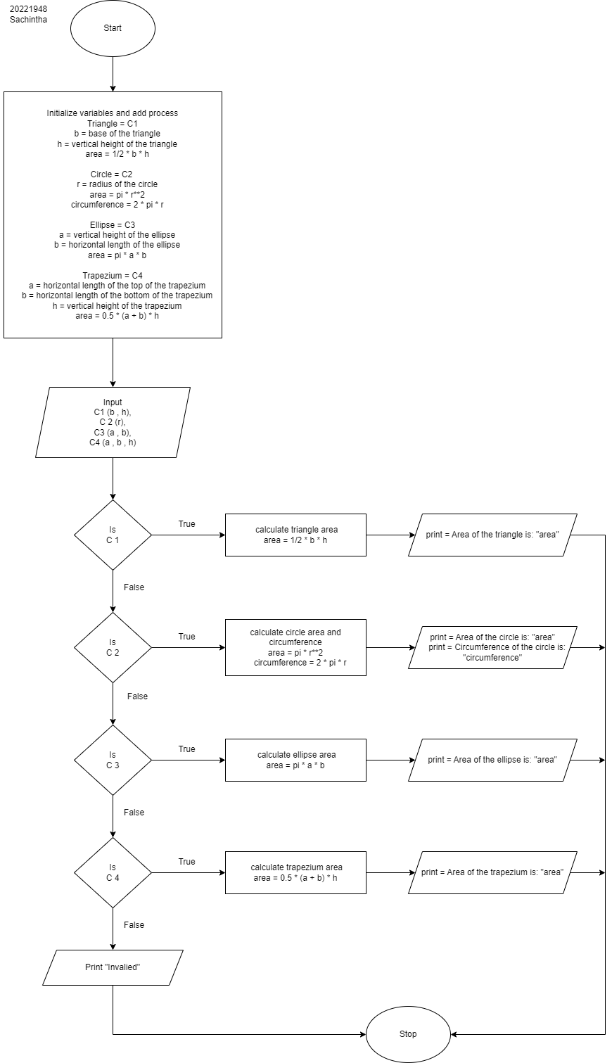Q 4,